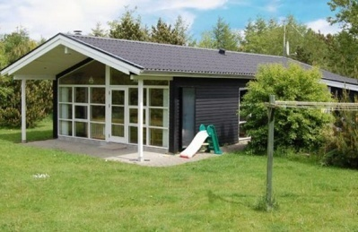
Tenancy

1. When entering into the rental agreement the tenant agrees to the rental conditions below being a part of the rental agreement.
2. The price does not include the use of the following:
Electricity: 0, 30 Euro
Cleaning: 105 Euro
Sheets: 7 Euro For one sheets

3. Place of key
Key box is beside the door. 1 week before your arrival we will send code for the key box.
4. Arrival and departure
Date of arrival and departure: Saturday Time of arrival (local time) 04.00 p.m. Time of departure (local time) 10.00 a.m.

5. Cleaning
The tenant must clean the holiday home and at departure the holiday home must be tidy and clean. It is possible to pay the owner or others to clean the holiday home. Price 105 Euro.

6. Rental agreement
Binding rental agreement between the tenant and the owner takes places by: E-mail

7. Terms of payment
25% of the rent is to be paid no later than 10 days after entering into the rental agreement with the owner. The remainder is to be paid no later than 30 days before date of arrival. In case payment of the first installment is not on time the reservation is canceled automatically.

8. Deposit
In addition to the 2 installment a deposit on 105 Euro of rent is to be paid. The deposit is to be paid back by the owner no later than 10 days after date of departure. Deductions for the use of water: heating etc. may occur.
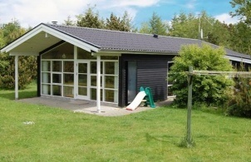
9. Method of payment
Money transfer to the bank account See Rental agreement
10. Cancellation
If cancellation takes place more than 30 days before arrival a 20 % fee is to be paid. In the case of cancellation between 30 and 10 days before arrival a 50 % fee is to be paid. In case of cancellation less than 10 days before arrival the full rental price is to be paid.
11. Compensation
The tenant shall be liable for everything belonging to the holiday home and shall compensate all damage to the holiday home or furniture caused by him during his stay. Should such damage occur during the tenancy period the tenant shall be obliged to inform the owner immediately. Contact Heidi 22563636
12. Force Majeure
If the tenancy is prevented because of force majeure (catastrophes, strikes, wars, riots or similar) the owner shall not be liable for disrupted or non stays.
13. Defects and complaints
Complaints of defects in the holiday home shall be reported immediately to the owner, who will try to remedy the defect as quickly as possible. However, the tenant cannot make up a claim in case of unpredicted disturbances, damage and power cuts. This also applies to the piping and sanitary appliances.
14. The tenant must bring the following:
The tenant must bring bed linen (sheets, duvet and pillow covers), tea towels, tablecloths, dishcloths, towels and cleaning materials.
15. Miscellaneous
The holiday home may only be occupied by as many people as there are beds. Unless otherwise agreed with the owner, tents and caravans are not allowed on the property.

Best Regards
Heidi & Michael
Nøddehaven 37
6840 Oksbøl

